1. Create one VPC,with 1 one public subnet and 1 private subnet.

1. Enable VPC peering for cross region.

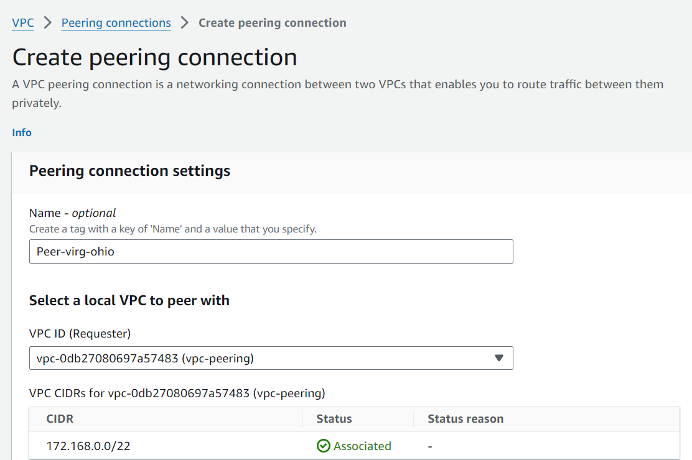

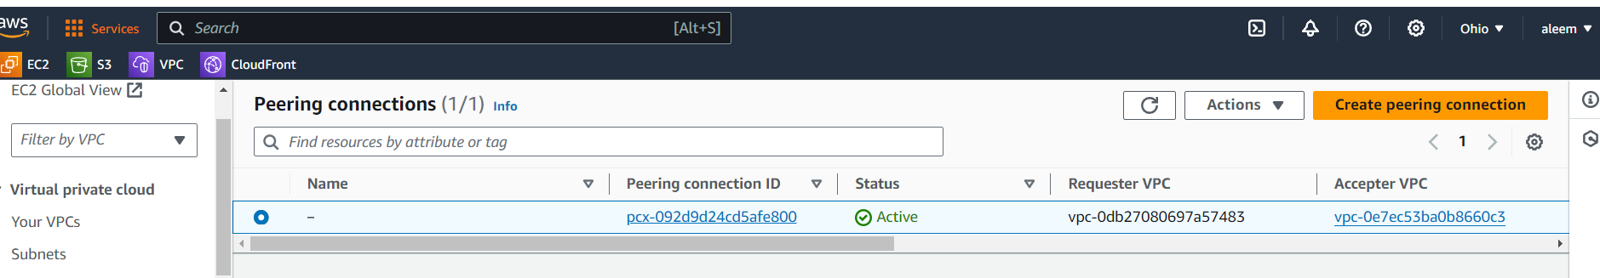

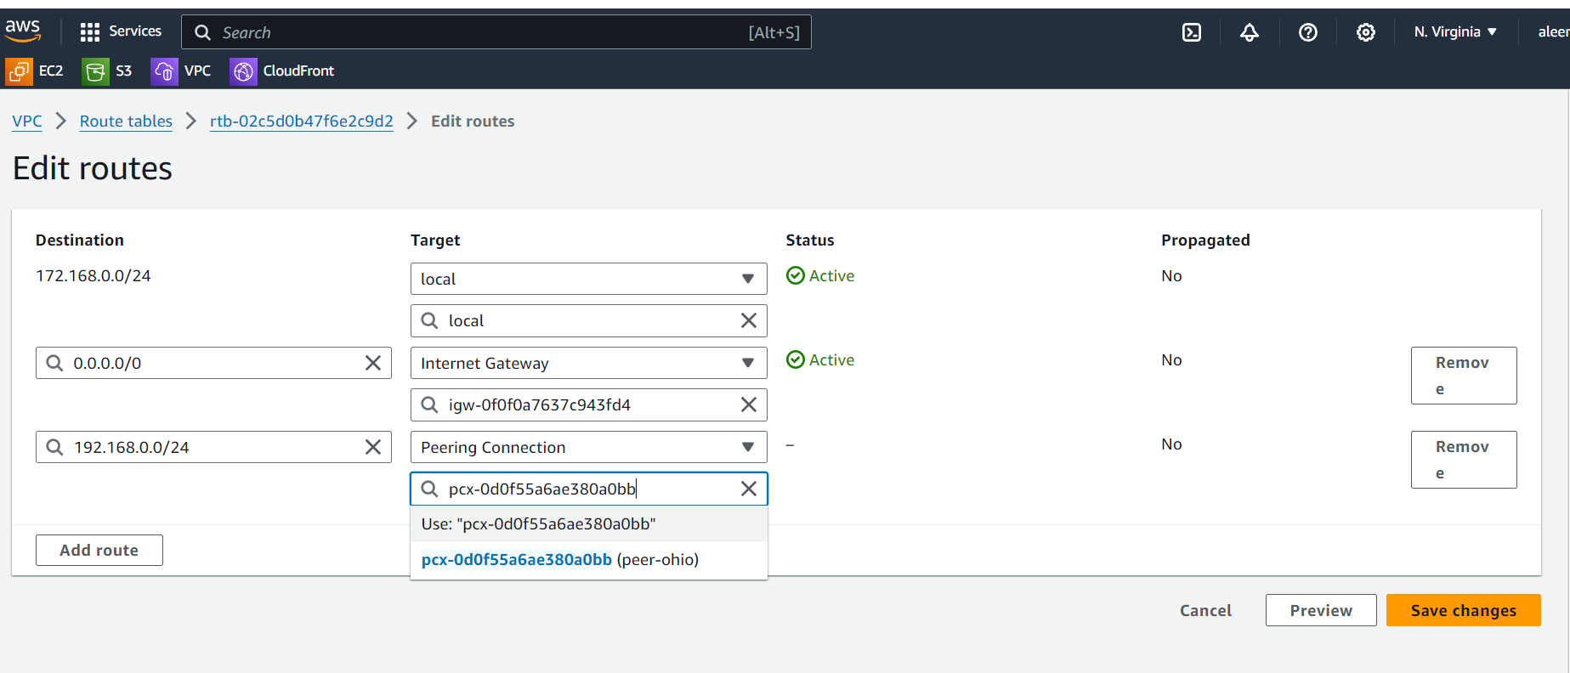

**Route table must add in both sides to send traffic between peering   
connections.**

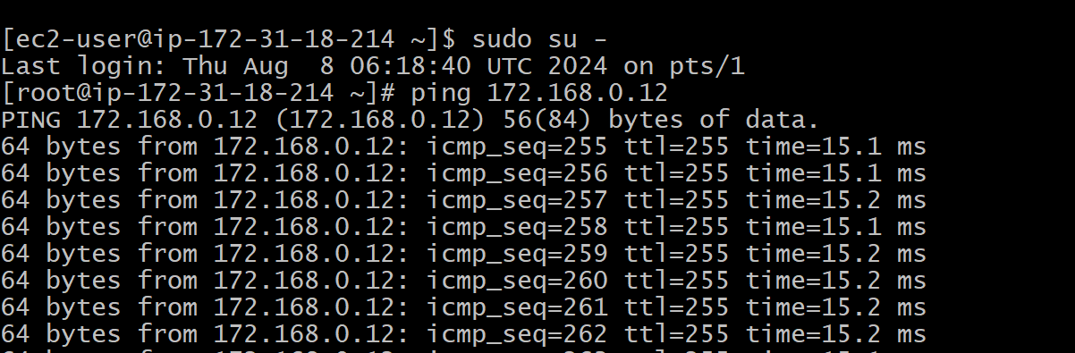

1. Enable VPC peering for cross account. (You can collaborate with your friend and do this task).

**Ask account Id, VPC ID, Region, CIDR range from another account to create peering**

**Add the CIDR range of the other PVC in our route table and ask them the same to change in route table**

**Now check the private address of another account**

4) Bash script to setup one vpc,1 public and 1 private subnet with IGW,RT and need to launch one ec2 in public

and one ec2 in private in `SEOUL REGION` ONLY.



